LK Vertical Long Shaft Pump(Rotor extractable type),Vertical Mixed Flow Pump

Description
The said series pumps are used to transfer clear water,rain water,water in iron sheet pits,sewage and seawater,servicing in power plants,iron and steel works,water supply companies,sewage treatment plants,petroleum and chemical industries,mines as well as municipal water supply and drainage projects,farmlands irriagation,flood protection and drain waterlogged farmlands,etc..The temperature of pumped media is below 55⁰C and reaches to 90⁰C for special design. The flow rate ranges from 30 to 20000m³/h and the head—from 7 to 200m.

Features
1. Operation smooth,safe and reliable,starting without exhausting vacumn,service life long.
2. The volumn of the pump small,less occupied land area, the length under foundation adjustable,applicability strong.
3. Flowing channel simple and reliable,saving the investment for construction of the pump house.
4. Structure reasonable,convenient for mounting and dismantling,,easy to maintain and inspect.
5. Efficiency high, operating cost reduced.

Model description
1400LK-30Ⅰ

1400—Outlet of the pump:1400mm
L----Vertical mixed flow pump
K----Pull-out rotor
30---Design head
Ⅰ---Pump design class(no mark when
first time design)
Remarks: multistage type is usually
Not designed for the pump of large
nozzle diameter.

Structure feature:

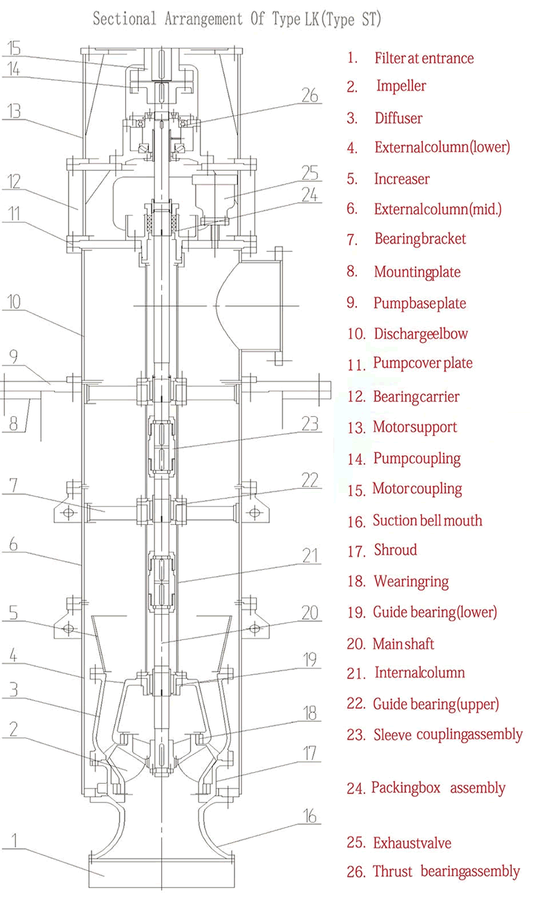
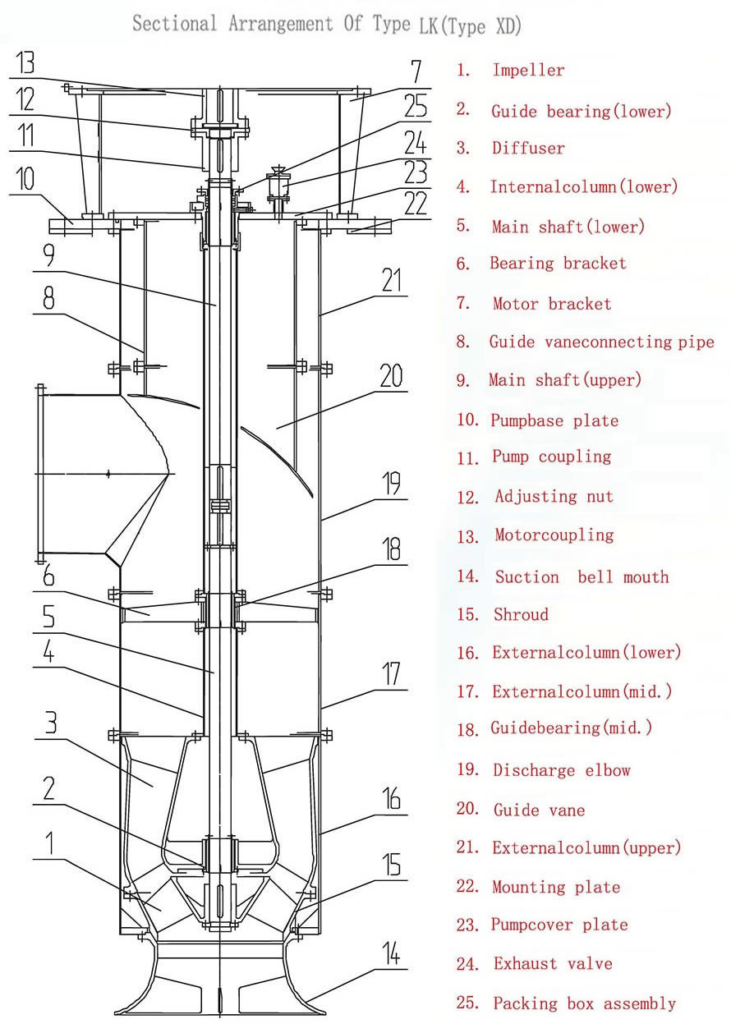

1. Series LK ,LB pumps are of vertical single stage and/or multistage centrifugal or mixed flow with diffuser types.
2. The following structure types are available for the pump:the discharge opening above and/or under the mounting foundation(Type Code named S and X respectively);the axial thrust force born by the pump and/or by the motor(Type Code named T and D);lubricating water from outside and/or from the pump itself.
3. The intake sump is of wet pit and/or dry pit types.
Wet pit type:lower part of the pump inundated in the intake sump.
Dry pit type:the water enters into the pump,the suction bellmouth is connected with the inlet pipe of the pump by means of elbow bend pipe of 90.
4. Rubber guide bearings and /or the Thordon guide bearings are available for bearings of the pump.
5. Generally when the nozzle diameter of the pump is under 1000mm , non pull-out type is adopted for the rotor and the discharge opening is above the mounting foundation(Type Code named ST). In this case the axial thrust force and the weight of the rotor are usually born by thrust bearings of the pump itself and flexible connection is adopted between the pump and the motor.The thrust force and the weight of the rotor can also be born by the motor if required,or other structure types such as SD,XT,XD are available .Rotor pull-out type can also be adopted if required by clients.
Generally when the discharge diameter of the pump is above 1000mm, pull-out type is adopted for the rotor and the discharge opening is under the mounting foundation(Type Code named XD).In this case the axial thrust force and the weight of the rotor are usually born by thrust bearings of the motor and rigid connection is adopted between the pump
and the motor. The axial thrust force and the weight of the rotor can also be born by
the pump if required,or other structure types such as XT,SD,ST are available .Rotor non pull-out type can also be adopted if required by clients.
6. When the axial thrust force and the weight of the rotor are born by pump itself,the thrust bearing of the pump is lubricated with dilute oil and is equipped with a temperature detector Pt100 to detect bearing temperature and a pressure type thermometer to detect the temperature of lubricating oil.
7. The antielectrochemical corrosion appliance is adopted for the part of the pump contacting the liquid to ensure the service life of the pump when seawater is pumped.
8. The packing seal is adopted for the axial seal of the pump.
9. The clearance between the impeller and the impeller chamber,i.e.the rotating component and the static component,can be easily adjusted on the pump mounting foundation.
Materials Of Major Parts
Media  Parts | Clear water | Seawater | Sewage（incl.of abrasiv powder）
Discharge elbow  Intermediate column (internal & external) | Q235-A | HT200Ni2Cr  0Cr18Ni9  ZG0Cr18Ni12Mo2 | Q235-A
Guide vane,  Suction bellmouth | HT200 | HT200Ni2Cr  ZG0Cr18Ni9  ZG0Cr18Ni12Mo2 | HT200、QT500-7  ZG1Cr13Ni1
Impeller | ZG1Cr13Ni1 HT200 | ZG0Cr18Ni9  ZG0Cr18Ni12Mo2 | QT500-7  ZG1Cr13Ni1
Shroud,wearing ring | HT200  ZG2Cr13 | ZG0Cr18Ni9  ZG0Cr18Ni12Mo2 | ZG1Cr13Ni1  QT500-7
Main shaft | 45、2Cr13 | 2Cr13、0Cr18Ni9  0Cr18Ni12Mo2 | 45、2Cr13  1Cr18Ni9
Shaft sleeve | 45,2Cr13 | 2Cr13、0Cr18Ni9  ZG0Cr18Ni12Mo2 | 2Cr13、1Cr18Ni9
Guide bearing | HT200+abrasive rubber  HT200+Thordon bearing | HT200+abrasive rubber  HT200+Thordon bearing | HT200+abrasive rubber  HT200+Thordon bearing

Remarks:Other materials are available at the request of clients.Cast iron is suitable only for closed type impeller.

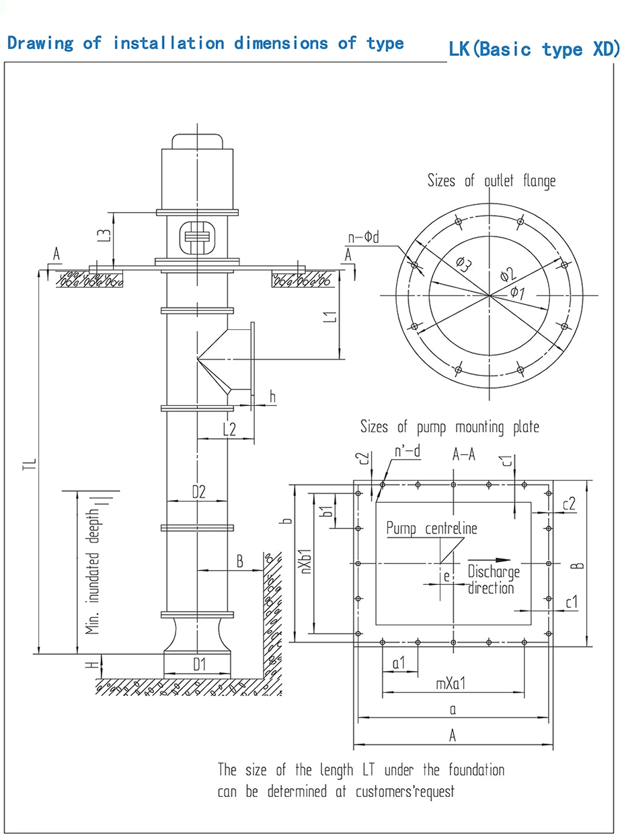

Performance Data
Type | Flow rate |  | Head | Rotation speed | Brake power | Matched power |  | Eff. | NPSHr | Nozzle dia.. | Weight of  motor
 | Q |  | H | n | Pa | power | Type | η
 | m³/h | L/s | m | r/min | KW | KW |  | % | m | mm | Kg
1000LK-9.4 | 8877 | 2465.8 | 10.8 | 495 | 314 | 355 | YL5003-12 | 83.5 | 6.7 | 936 | 4250
 | 10087 | 2802.0 | 9.4 |  | 295 |  |  | 87.7 | 6.9
 | 11387 | 3163.2 | 6.9 |  | 257 |  |  | 83.5 | 7.3
1000LK-9.9 | 6700 | 1861.1 | 11.4 | 590 | 250 | 280 | YL4503-10 | 83.0 | 7.0 | 806 | 3270
 | 7614 | 2114.9 | 9.9 |  | 235 |  |  | 87.3 | 7.2
 | 8595 | 2387.5 | 7.2 |  | 204 |  |  | 83.0 | 7.7
1000LK-10.5 | 7341 | 2039.2 | 12.1 | 590 | 290 | 315 | YL4504-10 | 83.1 | 7.4 | 831 | 3330
 | 8342 | 2317.3 | 10.5 |  | 273 |  |  | 87.4 | 7.7
 | 9417 | 2615.9 | 7.7 |  | 237 |  |  | 83.1 | 8.1
1000LK-11.9 | 7007 | 1946.5 | 13.4 | 590 | 319 | 355 | YL4505-10 | 79.9 | 5.5 | 792 | 3450
 | 8069 | 2241.4 | 11.9 |  | 308 |  |  | 85.2 | 5.8
 | 8919 | 2477.4 | 10.2 |  | 305 |  |  | 81.2 | 7.7
1000LK-12.7 | 7678 | 2132.8 | 14.2 | 590 | 371 | 400 | YL5001-10 | 80.0 | 5.9 | 816 | 4000
 | 8841 | 2455.9 | 12.7 |  | 358 |  |  | 85.3 | 6.1
 | 9772 | 2714.4 | 10.9 |  | 355 |  |  | 81.4 | 8.2
1000LK-13.5 | 8413 | 2336.8 | 15.1 | 590 | 432 | 450 | YLS5002-10 | 80.1 | 6.3 | 841 | 4850
 | 9687 | 2690.9 | 13.5 |  | 416 |  |  | 85.4 | 6.5
 | 10707 | 2974.2 | 11.5 |  | 413 |  |  | 81.5 | 8.7
1000LK-18.6 | 6681 | 1855.9 | 20.9 | 590 | 451 | 500 | YL5004-10 | 84.5 | 5.4 | 892 | 4450
 | 7709 | 2141.4 | 18.6 |  | 451 |  |  | 86.3 | 5.9
 | 8634 | 2398.4 | 15.4 |  | 453 |  |  | 79.7 | 6.6
1000LK-19.7 | 7320 | 2033.5 | 22.2 | 590 | 524 | 560 | YL5004-10 | 84.6 | 5.7 | 919 | 4450
 | 8447 | 2346.3 | 19.7 |  | 525 |  |  | 86.4 | 6.3
 | 9460 | 2627.9 | 16.3 |  | 526 |  |  | 79.8 | 7.0
1000LK-21 | 8021 | 2228.0 | 23.6 | 590 | 610 | 710 | YL5601-10 | 84.7 | 6.1 | 947 | 6160
 | 9255 | 2570.8 | 21.0 |  | 611 |  |  | 86.4 | 6.7
 | 10366 | 2879.3 | 17.3 |  | 612 |  |  | 80.0 | 7.4
1000LK-41 | 7620 | 2116.8 | 44.3 | 495 | 1108 | 1600 | YL1600-12 | 82.9 | 6.1 | 1234 | 20300
 | 9144 | 2540.1 | 41.0 |  | 1193 |  |  | 85.5 | 7.0
 | 10770 | 2991.7 | 35.4 |  | 1252 |  |  | 82.9 | 8.5
1200LK-10 | 9726 | 2701.7 | 11.5 | 495 | 365 | 400 | YLT5004-12 | 83.6 | 7.1 | 964 | 4400
 | 11052 | 3070.1 | 10.0 |  | 344 |  |  | 87.7 | 7.3
 | 12477 | 3465.8 | 7.3 |  | 298 |  |  | 83.6 | 7.8
1200LK-10.7 | 10657 | 2960.2 | 12.2 | 495 | 424 | 450 | YLT5005-12 | 83.7 | 7.5 | 994 | 4550
 | 12110 | 3363.9 | 10.7 |  | 400 |  |  | 87.8 | 7.8
 | 13671 | 3797.4 | 7.8 |  | 347 |  |  | 83.7 | 8.3
1200LK-11.3 | 11676 | 3243.4 | 13.0 | 495 | 494 | 560 | YLT5602-12 | 83.8 | 8.0 | 1024 | 6360
 | 13269 | 3685.7 | 11.3 |  | 465 |  |  | 87.9 | 8.3
 | 14979 | 4160.8 | 8.3 |  | 404 |  |  | 83.8 | 8.8
1200LK-12.9 | 11146 | 3096.0 | 14.4 | 495 | 542 | 630 | YLT5603-12 | 80.7 | 6.0 | 977 | 6570
 | 12834 | 3565.1 | 12.9 |  | 524 |  |  | 85.8 | 6.2
 | 14185 | 3940.4 | 11.0 |  | 518 |  |  | 82.0 | 8.3
1200LK-13.7 | 12212 | 3392.3 | 15.3 | 495 | 630 | 710 | YLT6302-12 | 80.8 | 6.3 | 1006 | 10050
 | 14063 | 3906.3 | 13.7 |  | 609 |  |  | 85.9 | 6.6
 | 15543 | 4317.4 | 11.7 |  | 603 |  |  | 82.1 | 8.8
1200LK-14.3 | 9218 | 2560.4 | 16.1 | 590 | 502 | 560 | YLT5004-10 | 80.2 | 6.6 | 867 | 4450
 | 10614 | 2948.4 | 14.3 |  | 484 |  |  | 85.5 | 6.9
 | 11731 | 3258.7 | 12.3 |  | 480 |  |  | 81.6 | 9.2
1200LK-17.7 | 8852 | 2458.8 | 20.0 | 495 | 567 | 630 | YLT5603-12 | 85.0 | 5.1 | 1036 | 6570
 | 10214 | 2837.1 | 17.7 |  | 568 |  |  | 86.7 | 5.7
 | 11439 | 3177.6 | 14.7 |  | 568 |  |  | 80.3 | 6.3
1200LK-18.8 | 9699 | 2694.1 | 21.2 | 495 | 659 | 710 | YLT6301-12 | 85.0 | 5.5 | 1067 | 9600
 | 11191 | 3108.6 | 18.8 |  | 661 |  |  | 86.8 | 6.0
 | 12534 | 3481.6 | 15.6 |  | 661 |  |  | 80.4 | 6.7
1200LK-20 | 10627 | 2951.9 | 22.6 | 495 | 767 | 900 | YLT6303-12 | 85.1 | 5.8 | 1100 | 10450
 | 12262 | 3406.0 | 20.0 |  | 769 |  |  | 86.9 | 6.4
 | 13733 | 3814.8 | 16.6 |  | 768 |  |  | 80.6 | 7.1
1200LK-21.3 | 11644 | 3234.3 | 24.0 | 495 | 892 | 1000 | YLT6304-12 | 85.2 | 6.2 | 1133 | 10820
 | 13435 | 3731.9 | 21.3 |  | 895 |  |  | 86.9 | 6.8
 | 15047 | 4179.8 | 17.6 |  | 893 |  |  | 80.7 | 7.5
1200LK-22.3 | 8788 | 2441.2 | 25.1 | 590 | 709 | 800 | YL800-10 | 84.8 | 6.4 | 976 | 6360
 | 10140 | 2816.8 | 22.3 |  | 711 |  |  | 86.5 | 7.1
 | 11357 | 3154.8 | 18.4 |  | 711 |  |  | 80.1 | 7.9
1200LK-27.1 | 8507 | 2363.0 | 29.2 | 495 | 808 | 1120 | YLT6305-12 | 83.7 | 6.4 | 1034 | 11500
 | 11342 | 3150.6 | 27.1 |  | 985 |  |  | 84.8 | 7.2
 | 13469 | 3741.4 | 22.0 |  | 964 |  |  | 83.7 | 8.9
1200LK-30 | 9922 | 2756.0 | 32.4 | 495 | 1043 | 1400 | YL1400-12 | 83.9 | 7.1 | 1087 | 18000
 | 13229 | 3674.7 | 30.0 |  | 1271 |  |  | 85.0 | 8.0
 | 15709 | 4363.7 | 24.4 |  | 1244 |  |  | 83.9 | 9.8
1200LK-49.6 | 10143 | 2817.4 | 53.6 | 495 | 1778 | 2240 | YL2200-12 | 83.2 | 7.4 | 1355 | 17500
 | 12171 | 3380.9 | 49.6 |  | 1916 |  |  | 85.7 | 8.4
 | 14335 | 3982.0 | 42.8 |  | 2008 |  |  | 83.2 | 10.2
1200LK-58.7 | 9120 | 2533.3 | 63.4 | 590 | 1899 | 2240 | YL2500-10 | 82.9 | 8.8 | 1234 | 13500
 | 10944 | 3039.9 | 58.7 |  | 2045 |  |  | 85.5 | 10.0
 | 12889 | 3580.3 | 50.7 |  | 2146 |  |  | 82.9 | 12.1
1400LK-10 | 13187 | 3663.1 | 11.5 | 425 | 492 | 560 | YL560-14 | 84.1 | 7.1 | 1120 | 9000
 | 14985 | 4162.6 | 10.0 |  | 464 |  |  | 88.1 | 7.3
 | 16917 | 4699.1 | 7.3 |  | 402 |  |  | 84.1 | 7.8
1400LK-10.6 | 14449 | 4013.6 | 12.2 | 425 | 572 | 630 | YL630-14 | 84.2 | 7.5 | 1154 | 11800
 | 16419 | 4560.9 | 10.6 |  | 540 |  |  | 88.2 | 7.8
 | 18535 | 5148.7 | 7.8 |  | 468 |  |  | 84.2 | 8.3
1400LK-11.3 | 15831 | 4397.6 | 13.0 | 425 | 665 | 710 | YL710-14 | 84.3 | 8.0 | 1189 | 16000
 | 17990 | 4997.3 | 11.3 |  | 628 |  |  | 88.2 | 8.3
 | 20309 | 5641.3 | 8.3 |  | 544 |  |  | 84.3 | 8.8
1400LK-13.7 | 16558 | 4599.4 | 15.3 | 425 | 848 | 1000 | YL1000-14 | 81.4 | 6.3 | 1168 | 17000
 | 19066 | 5296.2 | 13.7 |  | 822 |  |  | 86.4 | 6.6
 | 21073 | 5853.7 | 11.7 |  | 812 |  |  | 82.7 | 8.8
1400LK-14.5 | 18142 | 5039.5 | 16.3 | 425 | 986 | 1250 | YL1250-14 | 81.5 | 6.7 | 1204 | 17500
 | 20891 | 5803.0 | 14.5 |  | 956 |  |  | 86.4 | 7.0
 | 23090 | 6413.8 | 12.4 |  | 944 |  |  | 82.8 | 9.4
1400LK-18.8 | 13150 | 3652.8 | 21.2 | 425 | 889 | 1000 | YL1000-14 | 85.5 | 5.4 | 1239 | 17000
 | 15173 | 4214.7 | 18.8 |  | 892 |  |  | 87.2 | 6.0
 | 16994 | 4720.5 | 15.6 |  | 889 |  |  | 81.0 | 6.7
1400LK-20 | 14408 | 4002.3 | 22.6 | 425 | 1034 | 1250 | YL1250-14 | 85.6 | 5.8 | 1277 | 17500
 | 16625 | 4618.0 | 20.0 |  | 1038 |  |  | 87.2 | 6.4
 | 18620 | 5172.2 | 16.5 |  | 1034 |  |  | 81.1 | 7.1
1400LK-21.3 | 15787 | 4385.2 | 24.0 | 425 | 1203 | 1400 | YL1600-14 | 85.7 | 6.2 | 1316 | 19000
 | 18216 | 5059.9 | 21.3 |  | 1207 |  |  | 87.3 | 6.8
 | 20401 | 5667.1 | 17.6 |  | 1202 |  |  | 81.3 | 7.5
1400LK-33.2 | 11572 | 3214.5 | 35.9 | 495 | 1345 | 1800 | YL1800-12 | 84.0 | 7.9 | 1143
 | 15430 | 4286.0 | 33.2 |  | 1640 |  |  | 85.1 | 8.8
 | 18323 | 5089.6 | 27.0 |  | 1604 |  |  | 84.0 | 10.9
1400LK-60 | 13500 | 3750.0 | 64.8 | 495 | 2852 | 3550 | YL3600-12 | 83.5 | 9 | 1488
 | 16200 | 4500.0 | 60.0 |  | 3076 |  |  | 86.0 | 10.2
 | 19080 | 5300.0 | 51.8 |  | 3222 |  |  | 83.5 | 12.4
1600LK-12 | 17346 | 4818.4 | 13.8 | 425 | 774 | 900 | YL900-14 | 84.4 | 8.5 | 1225
 | 19711 | 5475.4 | 12.0 |  | 731 |  |  | 88.3 | 8.8
 | 22252 | 6181.1 | 8.8 |  | 633 |  |  | 84.4 | 9.3
1600LK-12.8 | 19006 | 5279.4 | 14.7 | 425 | 900 | 1000 | YL1000-14 | 84.5 | 9.1 | 1262
 | 21598 | 5999.3 | 12.8 |  | 850 |  |  | 88.4 | 9.4
 | 24381 | 6772.6 | 9.4 |  | 736 |  |  | 84.5 | 9.9
1600LK-14.5 | 13381 | 3716.9 | 16.3 | 495 | 733 | 800 | YL800-12 | 81.0 | 6.7 | 1037
 | 15408 | 4280.0 | 14.5 |  | 709 |  |  | 86.0 | 7.0
 | 17030 | 4730.5 | 12.4 |  | 701 |  |  | 82.2 | 9.4
1600LK-15.4 | 19878 | 5521.6 | 17.3 | 425 | 1147 | 1250 | YL1250-14 | 81.6 | 7.2 | 1240
 | 22890 | 6358.3 | 15.4 |  | 1112 |  |  | 86.5 | 7.4
 | 25299 | 7027.5 | 13.2 |  | 1098 |  |  | 82.9 | 10.0
1600LK-16.4 | 21780 | 6050.0 | 18.4 | 425 | 1334 | 1600 | YL1600-14 | 81.8 | 7.6 | 1278
 | 25080 | 6966.6 | 16.4 |  | 1294 |  |  | 86.6 | 7.9
 | 27720 | 7700.0 | 14.0 |  | 1277 |  |  | 83.0 | 10.6
1600LK-22.6 | 17297 | 4804.8 | 25.5 | 425 | 1399 | 1600 | YL1600-14 | 85.8 | 6.5 | 1355
 | 19958 | 5544.0 | 22.6 |  | 1405 |  |  | 87.4 | 7.2
 | 22354 | 6209.3 | 18.7 |  | 1398 |  |  | 81.4 | 8.0
1600LK-24 | 18952 | 5264.6 | 27.1 | 425 | 1628 | 1800 | YL1800-14 | 85.8 | 7.0 | 1397
 | 21868 | 6074.5 | 24.0 |  | 1634 |  |  | 87.5 | 7.7
 | 24492 | 6803.4 | 19.9 |  | 1625 |  |  | 81.5 | 8.5
1600LK-33.3 | 15765 | 4379.1 | 36.0 | 425 | 1827 | 2500 | YL2500-14 | 84.5 | 7.9 | 1329
 | 21020 | 5838.8 | 33.3 |  | 2228 |  |  | 85.6 | 8.9
 | 24961 | 6933.6 | 27.1 |  | 2179 |  |  | 84.5 | 10.9
1800LK-12.2 | 23654 | 6570.5 | 14.0 | 367 | 1061 | 1250 | YL1250-16 | 84.9 | 8.6 | 1422
 | 26879 | 7466.5 | 12.2 |  | 1004 |  |  | 88.7 | 8.9
 | 30344 | 8428.9 | 8.9 |  | 868 |  |  | 84.9 | 9.4
1800LK-12.9 | 25917 | 7199.2 | 14.9 | 367 | 1234 | 1600 | YL1600-16 | 85.0 | 9.2 | 1465
 | 29451 | 8180.9 | 12.9 |  | 1168 |  |  | 88.7 | 9.5
 | 33247 | 9235.4 | 9.5 |  | 1010 |  |  | 85.0 | 10.0
1800LK-15.6 | 27106 | 7529.6 | 17.5 | 367 | 1571 | 1800 | YL1800-16 | 82.2 | 7.2 | 1440
 | 31213 | 8670.4 | 15.6 |  | 1527 |  |  | 86.9 | 7.5
 | 34499 | 9583.1 | 13.4 |  | 1505 |  |  | 83.4 | 10.1
1800LK-21.5 | 21528 | 5979.9 | 24.2 | 367 | 1650 | 1800 | YL1800-16 | 86.1 | 6.2 | 1528
 | 24840 | 6899.9 | 21.5 |  | 1658 |  |  | 87.7 | 6.9
 | 27820 | 7727.9 | 17.8 |  | 1646 |  |  | 81.8 | 7.6
1800LK-22.8 | 23587 | 6552.1 | 25.8 | 367 | 1920 | 2240 | YL2500-16 | 86.2 | 6.6 | 1574
 | 27216 | 7560.1 | 22.8 |  | 1929 |  |  | 87.8 | 7.3
 | 30482 | 8467.3 | 18.9 |  | 1914 |  |  | 81.9 | 8.1
1800LK-25.5 | 20766 | 5768.3 | 28.8 | 425 | 1894 | 2240 | YL2500-14 | 85.9 | 7.4 | 1439
 | 23961 | 6655.7 | 25.5 |  | 1902 |  |  | 87.6 | 8.2
 | 26836 | 7454.4 | 21.1 |  | 1890 |  |  | 81.6 | 9.0
1800LK-33.8 | 21600 | 6000.0 | 36.5 | 367 | 2525 | 3550 | YL3600-16 | 85.0 | 8 | 1546
 | 28800 | 8000.0 | 33.8 |  | 3081 |  |  | 86.0 | 9
 | 34200 | 9500.0 | 27.5 |  | 3012 |  |  | 85.0 | 11.1
2000LK-13.7 | 28397 | 7888.1 | 15.8 | 367 | 1436 | 1600 | YL1600-16 | 85.1 | 9.7 | 1510
 | 32269 | 8963.7 | 13.7 |  | 1359 |  |  | 88.8 | 10.1
 | 36428 | 10119.0 | 10.1 |  | 1174 |  |  | 85.1 | 10.6
2000LK-14.6 | 31114 | 8642.8 | 16.8 | 367 | 1670 | 1800 | YL1800-16 | 85.2 | 10.3 | 1555
 | 35357 | 9821.4 | 14.6 |  | 1581 |  |  | 88.9 | 10.7
 | 39914 | 11087.2 | 10.7 |  | 1366 |  |  | 85.2 | 11.3
2000LK-16.6 | 29700 | 8250.0 | 18.6 | 367 | 1827 | 2000 | YL2000-16 | 82.3 | 7.7 | 1484
 | 34200 | 9500.0 | 16.6 |  | 1776 |  |  | 87.0 | 8.0
 | 37800 | 10500.0 | 14.2 |  | 1750 |  |  | 83.5 | 10.7
2000LK-17.6 | 32542 | 9039.4 | 19.8 | 367 | 2125 | 2240 | YL2500-16 | 82.4 | 8.2 | 1529
 | 37472 | 10409.0 | 17.6 |  | 2067 |  |  | 87.1 | 8.5
 | 41417 | 11504.7 | 15.1 |  | 2035 |  |  | 83.6 | 11.4
2000LK-24.3 | 25844 | 7179.0 | 27.4 | 367 | 2234 | 2500 | YL2500-16 | 86.3 | 7.0 | 1622
 | 29820 | 8283.5 | 24.3 |  | 2244 |  |  | 87.9 | 7.8
 | 33399 | 9277.5 | 20.1 |  | 2226 |  |  | 82.0 | 8.6
2000LK-25.8 | 28317 | 7865.9 | 29.1 | 367 | 2599 | 3150 | YL3150-16 | 86.4 | 7.5 | 1671
 | 32674 | 9076.0 | 25.8 |  | 2611 |  |  | 87.9 | 8.2
 | 36595 | 10165.2 | 21.3 |  | 2589 |  |  | 82.2 | 9.1
2000LK-27.4 | 31027 | 8618.5 | 30.9 | 367 | 3023 | 3150 | YL3150-16 | 86.4 | 7.9 | 1721
 | 35800 | 9944.5 | 27.4 |  | 3038 |  |  | 88.0 | 8.8
 | 40096 | 11137.8 | 22.7 |  | 3010 |  |  | 82.3 | 9.7
2200LK-14.2 | 36801 | 10222.5 | 16.3 | 330 | 1911 | 2240 | YL2500-18 | 85.4 | 10.0 | 1701
 | 41819 | 11616.5 | 14.2 |  | 1811 |  |  | 89.1 | 10.4
 | 47209 | 13113.7 | 10.4 |  | 1563 |  |  | 85.4 | 11.0
2200LK-15.1 | 40322 | 11200.6 | 17.3 | 330 | 2223 | 2500 | YL2500-18 | 85.5 | 10.7 | 1753
 | 45821 | 12728.0 | 15.1 |  | 2108 |  |  | 89.1 | 11.0
 | 51726 | 14368.5 | 11.0 |  | 1819 |  |  | 85.5 | 11.7
2200LK-18.8 | 35655 | 9904.3 | 21.0 | 367 | 2471 | 2800 | YL3150-16 | 82.5 | 8.7 | 1575 | 25000
 | 41058 | 11404.9 | 18.8 |  | 2405 |  |  | 87.2 | 9.0
 | 45380 | 12605.5 | 16.0 |  | 2367 |  |  | 83.7 | 12.1
2200LK-22.2 | 35579 | 9883.0 | 25.0 | 292 | 2790 | 3150 | YL3150-20 | 86.8 | 6.4 | 1940 | 32000
 | 41052 | 11403.5 | 22.2 |  | 2805 |  |  | 88.3 | 7.1
 | 45979 | 12771.9 | 18.3 |  | 2774 |  |  | 82.7 | 7.8
2200LK-23.5 | 38983 | 10828.6 | 26.6 | 292 | 3246 | 3550 | YL3600-20 | 86.8 | 6.8 | 1999 | 35000
 | 44980 | 12494.6 | 23.5 |  | 3263 |  |  | 88.4 | 7.5
 | 50378 | 13993.9 | 19.5 |  | 3226 |  |  | 82.8 | 8.3
2200LK-28.3 | 40209 | 11169.1 | 31.9 | 330 | 4027 | 4500 | YL4500-18 | 86.8 | 8.2 | 1940 | 37000
 | 46395 | 12887.5 | 28.3 |  | 4048 |  |  | 88.3 | 9.0
 | 51962 | 14434.0 | 23.4 |  | 4004 |  |  | 82.7 | 10.0
2400LK-16 | 44180 | 12272.3 | 18.4 | 330 | 2586 | 2800 | YL2800-18 | 85.6 | 11.3 | 1806 | 25000
 | 50205 | 13945.8 | 16.0 |  | 2453 |  |  | 89.2 | 11.7
 | 56676 | 15743.3 | 11.7 |  | 2116 |  |  | 85.6 | 12.4
2400LK-25 | 42713 | 11864.7 | 28.2 | 292 | 3776 | 4000 | YL4000-20 | 86.9 | 7.2 | 2060 | 37000
 | 49284 | 13690.1 | 25.0 |  | 3797 |  |  | 88.4 | 8.0
 | 55198 | 15332.9 | 20.7 |  | 3752 |  |  | 82.9 | 8.8
2600LK-15 | 51422 | 14284.0 | 17.3 | 292 | 2821 | 3150 | YL3150-20 | 85.9 | 10.7 | 1975 | 32000
 | 58435 | 16231.8 | 15.0 |  | 2677 |  |  | 89.4 | 11.0
 | 65966 | 18323.9 | 11.0 |  | 2308 |  |  | 85.9 | 11.7
2600LK-16 | 56343 | 15650.7 | 18.4 | 292 | 3282 | 3550 | YL3550-20 | 86.0 | 11.3 | 2035 | 35000
 | 64026 | 17784.9 | 16.0 |  | 3116 |  |  | 89.5 | 11.7
 | 72278 | 20077.2 | 11.7 |  | 2685 |  |  | 86.0 | 12.4
2600LK-26.6 | 46800 | 13000.0 | 30.0 | 292 | 4393 | 4800 | YL4800-20 | 87.0 | 7.7 | 2122 | 40000
 | 54000 | 15000.0 | 26.6 |  | 4418 |  |  | 88.5 | 8.5
 | 60480 | 16800.0 | 22.0 |  | 4364 |  |  | 83.0 | 9.4

